Table of Contents
1 Overview 2
2 Account Correlation Identification 2
3 Account Disable Status Identification 3
4 Account Lock Status Identification 4
5 Authoritative Applications Identification 4
6 Delimited File Pre-Iterate Rule 5
7 Aggregation Data Flow 5
8 Requestable Entitlement Manual Override 9
9 Additional Aggregation Rules 9

Document Revision History
Version | Date | Status | Author | Summary of Changes
Version 1 | 3/2/18 |  | Rohit Gupta
Version 2 | 4/5/18 |  | Cathy Mallet | Minor grammar/spelling/etc edit

Overview
The purpose of this document is to explain the technical details of the Aggregation feature that is bundled with the Accelerator Pack. This feature provides an aggregation intake form for an application either via the Self Service Onboarding Wizard or the IdentityIQ Administrative Wizard.

Account Correlation Identification
Accounts can be correlated using two types of String Format. One is with String Comparison Operation and the other is without String Comparison Operation. This correlation identification applies to regular/primary and privileged/secondary accounts that are aggregated from an application. The name of the attribute that is used for this definition on an application is “accountCorrelationAttrExpression”.

The “Rule-Framework-Correlation” rule must be selected as a correlation rule on an application. This rule is automatically set from the Self Service Onboarding Wizard.

A correlation that requires an “OR” condition must be defined on the application as CorrelationConfig Rule “Rule-FrameWork-Correlation”. This rule uses CorrelationConfig for correlation, and if it is not defined it falls back to String Format. Any unmatched account would end up as an uncorrelated Identity Cube. All the string operation comparisons are case insensitive.

Please Note: The same rule correlates service/non-interactive/shared accounts to service Identity Cubes first, and then correlates privileged/secondary/interactive and regular/primary accounts to authoritative source Identity Cubes.

Example of String Format without Comparison Operation “[Cube Attribute Name]#IIQCorrelated#[Schema Attribute Name]”. The default operation for this format is “EQUALS”.

String Tokens and Separators | Description
[Cube Attribute Name] | Identity Cube Attribute Name
#IIQCorrelated# (Token Separator) | Token to Separate Identity Cube Attribute Name and Application Schema Attribute Name
[Schema Attribute Name] | Application Schema Attribute Name

Example of String Format with Comparison Operation “[Cube Attribute Name]#IIQCorrelated#[Schema Attribute Name]#IIQCorrelated#[Operation]”. This format and rule “Rule-FrameWork-Correlation” is automatically set from Self Service Onboarding Wizard.

String Tokens and Separators | Description
[Cube Attribute Name] | Identity Cube Attribute Name
#IIQCorrelated# (Token Separator) | Token to Separate Identity Cube Attribute Name and Application Schema Attribute Name
[Schema Attribute Name] | Application Schema Attribute Name
#IIQCorrelated# (Token Separator) | Token to Separate Schema Attribute Name and Operation
[Operation] | STARTSWITH  ENDSWITH  CONTAINS  EQUALS

Account Disable Status Identification
Account disable status can be identified using String Format with Comparison Operation or String Format with Java Regular Expression. The name of the attribute that is used for this definition on an application is “accountDisableAttrExpression”. This identification applies to all accounts that are aggregated from an application. Internally, in IdentityIQ an account’s disable status is set via the “IIQDisabled” attribute. This is defined only when connector is not explicitly setting the attribute “IIQDisabled”.

The “Rule-Framework-RapidAppOnBoarding-Customization-Rule” rule must be selected as a customization rule on an application. This rule is automatically set from the Self Service Onboarding Wizard.

During aggregation, the “Rule-FrameWork-Disabled” rule promotes the link “IIQDisabled” attribute status to an extended searchable link attribute “disabledAccount”.

Example of String Format with Operation “[Schema Attribute Name]#IIQDisabled#[Schema Attribute Value]#IIQDisabled#[Operation]”. This format is automatically set from the Self Service Onboarding Wizard.

String Tokens and Separators | Description
[Schema Attribute Name] | Application Schema Attribute Name
#IIQDisabled# (Token Separator) | Token to Separate Identity Schema Attribute Name and Schema Attribute Value
[Schema Attribute Value] | Application Schema Attribute Value
#IIQDisabled# (Token Separator) | Token to Separate Schema Attribute Value and Operation
[Operation] | STARTSWITH  ENDSWITH  CONTAINS  EQUALS

Example of String Format with Java Regular Expression “[Schema Attribute Name]#IIQDisabled#[Java Regular Expression]”.

String Tokens and Separators | Description
[Schema Attribute Name] | Application Schema Attribute Name
#IIQDisabled# (Token Separator) | Token to Separate Application Schema Attribute Name and Java Regular Expression
[Java Regular Expression] | This is executed against the Application Schema Attribute Value obtained from Application Schema Attribute Name on the “Link” Object

Account Lock Status Identification
The account lock status can be identified using String Format with Comparison Operation or String Format with Java Regular Expression. The name of the attribute that is used for this definition on an application is “accountLockAttrExpression”. This identification applies to all accounts that are aggregated from an application. Internally, in IdentityIQ, the account’s lock status is set via attribute “IIQLocked”. This is defined only when connector is not explicitly setting the attribute “IIQLocked”.

The “Rule-Framework-RapidAppOnBoarding-Customization-Rule” rule must be selected as a customization rule on an application. This rule is automatically set from the Self Service Onboarding Wizard.

During aggregation, the “Rule-FrameWork-Locked” rule promotes the link “IIQLocked” attribute status to an extended searchable link attribute called “lockedAccount”.

Example of String Format with Operation “[Schema Attribute Name]#IIQLocked#[Schema Attribute Value]#IIQLocked#[Operation]”. This format is automatically set from the Self Service Onboarding Wizard.

String Tokens and Separators | Description
[Schema Attribute Name] | Application Schema Attribute Name
# IIQLocked # (Token Separator) | Token to Separate Identity Schema Attribute Name and Schema Attribute Value
[Schema Attribute Value] | Application Schema Attribute Value
#IIQLocked# (Token Separator) | Token to Separate Schema Attribute Value and Operation
[Operation] | STARTSWITH  ENDSWITH  CONTAINS  EQUALS

Example of String Format with Java Regular Expression “[Schema Attribute Name]#IIQLocked#[Java Regular Expression]”.

String Tokens and Separators | Description
[Schema Attribute Name] | Application Schema Attribute Name
#IIQLocked# (Token Separator) | Token to Separate Application Schema Attribute Name and Java Regular Expression
[Java Regular Expression] | This is executed against the Application Schema Attribute Value obtained from Application Schema Attribute Name on the “Link” Object

Authoritative Applications Identification
Application ObjectConfig is extended with four non-indexed attributes that are used to classify an authoritative application as per population type aka user type. An application is considered authoritative if “authoritative” property of an application is “true”. These attributes are used during execution of “Create Identity” and “Edit Identity” QuickLinks workflows to provision authoritative identity cube changes from IdentityIQ to the end-system. The pre-requisite configurations that are required to provision cube changes from IdentityIQ to authoritative sources are listed below.

Configurations on Authoritative Applications
- Create and Edit Provisioning Policies must be mined and configured on authoritative source applications
- PROVISIONING feature must be added to “featureString” on an application
Authoritative Application Attributes
- Employee Authoritative Source (authoritativeEmployee): This is used for Employee Identity Cubes.
- Service Account Authoritative Source(authoritativeServiceAccount): This is used for Service Account Identity Cubes. These cubes are identified using an extended attribute “serviceCube”
- Non-Employee Authoritative Source (authoritativeNonEmployee): This is used for Contractor Identity Cubes.
- Repository can be authoritative source for both Employees and Contractors. In this case User Type must be set using Identity Mapping Rules.

Delimited File Pre-Iterate Rule
This rule validates flat file connector data and returns a file stream for the delimited file connector to process. This rule is applied only if the application is configured for “File Transport” as “local”. It performs validation against any object type. The “Rule-FrameWork-Preiterate-DelimitedFile” rule is saved on application during Self Service Onboarding of flat file applications. Here is the list of functions that are performed by this rule.
- Validation of Application Schema Attributes
- Validates that “Identity Attribute” is configured on the application
- Validates the presence of the “Identity Attribute” name in the File Header. This validation only applies to connectors that are configured to have “File has column header on first line”
- The schema attributes can be marked as required using the SailPoint Debug Page. The required=”true” property must be defined on the AttributeDefinition of each required schema attribute
  - Validates that the required schema attribute is present in header of a file, if the file is configured to have a header in the first line
  - Validates that the number of columns in a file is not less than number of required schema attributes. The number of required schema attributes can be the same as or can exceed the number of columns in the file
- Converts Index key to upper case if merge is required and the file is not sorted
- This merges the flat file data properly; otherwise the last record wins and results in inaccurate aggregated data.

Aggregation Data Flow
The “Rule-Framework-RapidAppOnBoarding-Customization-Rule” customization rule is used for all regular/primary or secondary/privileged or service accounts. It sets account disable, lock, privileged and service account status.

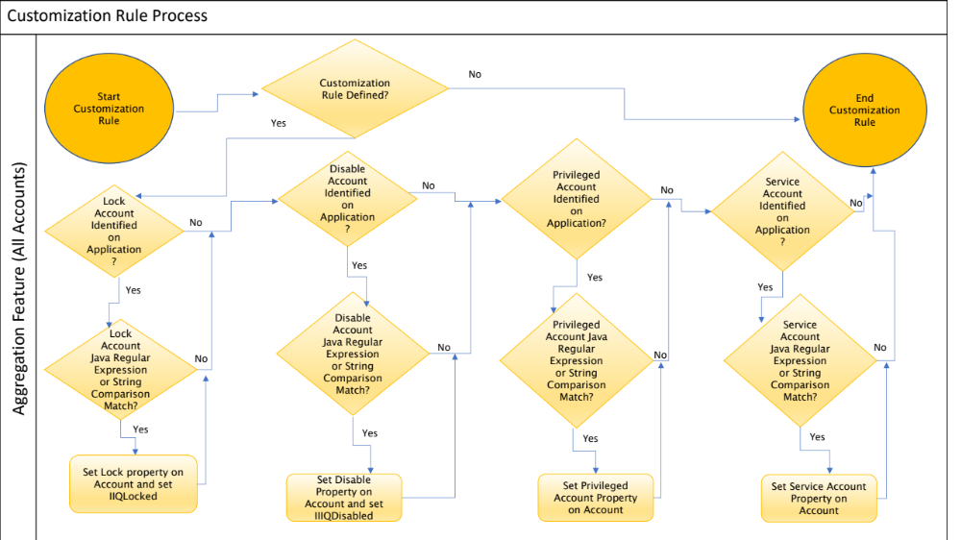

The “Rule-FrameWork-Correlation” correlation rule is used for all accounts. It correlates service accounts first,then correlates regular/primary and privileged/secondary accounts.
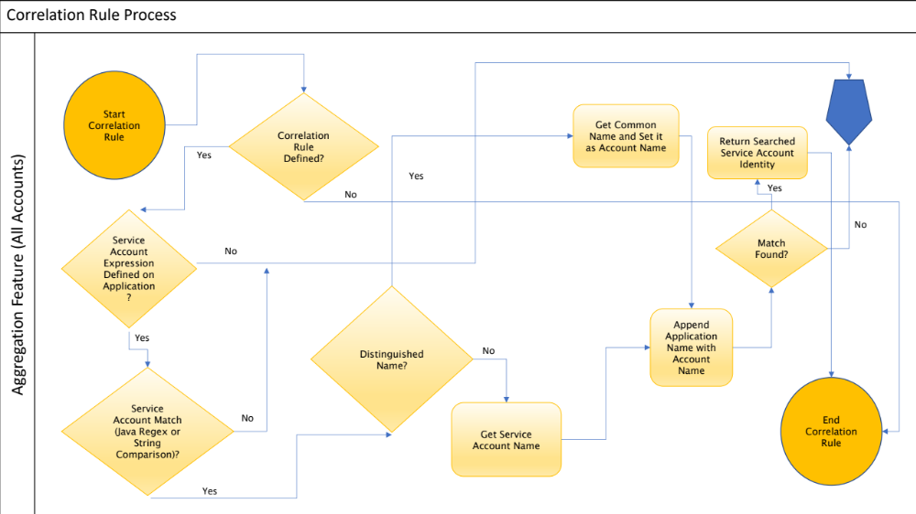

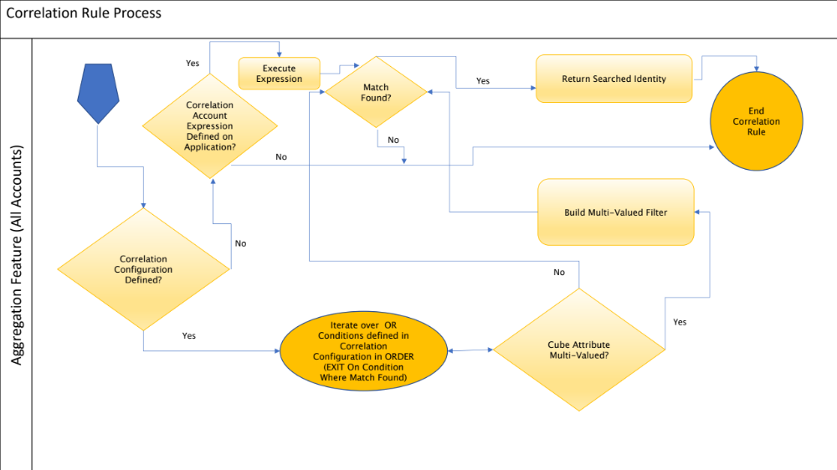

This is the Pre-Iterate Rule “Rule-FrameWork-Preiterate-DelimitedFile” flow. This rule is used to validate flat file data and converts the identity attribute key to upper case if a merge is required and the file is not sorted.
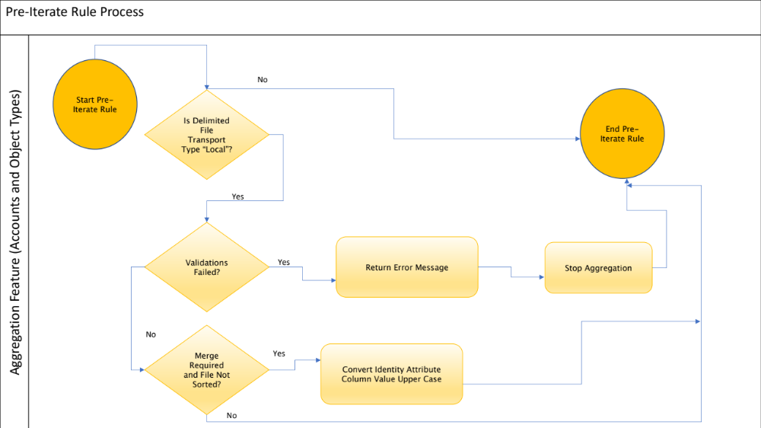

This is the Managed Entitlement Customization Rule “Rule-FrameWork-Promote-Managed-Attribute” flow. This rule marks entitlements as birthright or privileged, sets the business application name as the logical business application name, and turns off the request ability of infrastructure/ infrastructure/technology applications that don’t have logical business application names tied to them. This rule executes only for new entitlements. It is configured automatically by the Self-Service Wizard,or can be configured manually on the application.

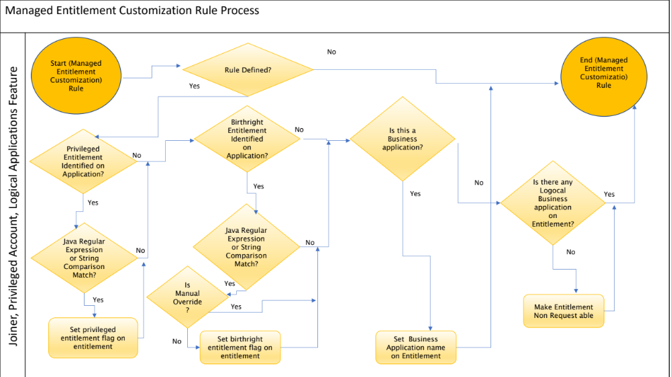

This is the Group Refresh Rule “Rule-FrameWork-Group-Refresh” flow. This rule marks entitlements as birthright or privileged, sets the business application name as the logical business application name, turns on the request ability of business application entitlements, and turns off the request ability of infrastructure/technology application entititlements that don’t have logical business application names tied to them. This rule executes for old and new entitlements. It must be configured for group aggregation tasks.

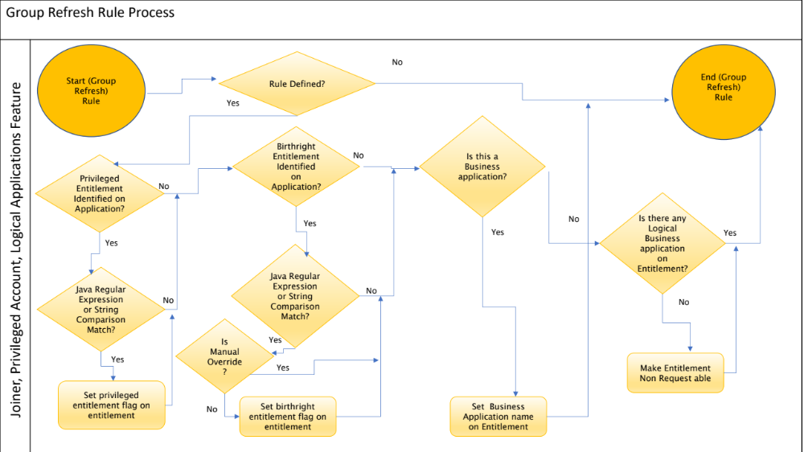

Requestable Entitlement Manual Override
This sub-feature is mainly used by the operations team to override the request ability of entitlements programmatically. The IdentityIQ Entitlement Catalog interface can be used to mark entitlements request ability. To ensure this value is not overridden, the next time the group refresh rule “Rule-FrameWork-Group-Refresh” executes, the “Manual Override” attribute must be set to “TRUE”. By default, an empty value for this attribute means “FALSE”.

Additional Aggregation Rules
Accelerator Pack comes with packaged customization, creation, correlation, group refresh, pre-iterate, after provisioning, and managed entitlement rules. In order to apply customer specific rules, additional rules can be used per application account and group aggregation. The input and output arguments of these additional rules are the same as the out of the box rules. These rules can be configured using IdentityIQ Administrative page.

- Additional Global Customization Rule
  - This rule will be invoked from rule “Rule-Framework-RapidAppOnBoarding-Customization-Rule”
- Additional Creation Rule
  - This rule will be invoked from rule “Rule-FrameWork-Creation” and “Rule-FrameWork-Creation-Joiner-Authoritative-Source”
- Additional Correlation Rule
  - This rule will be invoked from rule “Rule-FrameWork-Correlation”
- Additional Managed Attribute Customization Rule
  - This rule will be invoked from rule “Rule-FrameWork-Promote-Managed-Attribute”
- Additional Managed Attribute Group Refresh Rule
  - This rule will be invoked from rule “Rule-FrameWork-Group-Refresh”
- Additional After Provisioning Rule
  - This rule will be invoked from rule “Rule-Audit-Framework”
  - This rule will be invoked from rule “Rule-AccountCreation-Dependency-Framework”
- Additional Pre-Iterate Rule
  - This rule will be invoked from rule “Rule-FrameWork-Preiterate-DelimitedFile”

